GTB  
  
**QA**  
[DEV 20.14] OT-841 | XT | DK | AS | Request a Contact Popin v1 – 6 April 2020

**Jira ticket:**  
<https://jira.uhub.biz/browse/GTBEMEAOPT-841>

**Site**  
<https://www.ford.dk/>

**Test location**  
All pages except on BnP

**Hypothesis**  
Analysis on the TDR Popin and UC5 has shown that TDR Popin converts at a higher rate than UC5 for TDR Completes. We know that we can expect the conversion rate to be 100% higher than onsite conversion. As such, we want to ensure we keep leveraging this popin and its audience even during the pandemic. However, we will be shifting our focus to "Contact Us" to maintain a touch-free approach.

**Test Description**

View the BnP Start and Finish link. Click on the "Byg din Ford” link in the main heading. On the left there’s an option to pick "Personbiler” or “Varebiler” ~ Select vehicles from both sides.  
  
Next view the “Only on profile script true” link. If the vehicle has Test Drives available a popup will appear 10 seconds after viewing the page. You can view a list of the vehicles that can be test driven by clicking the “Test Drive Link” underneath the extra links. Due note however that just because the vehicle can be test driven, does not mean it will be available on the “Byg din Ford” page.

The popup that appears should look something like this:

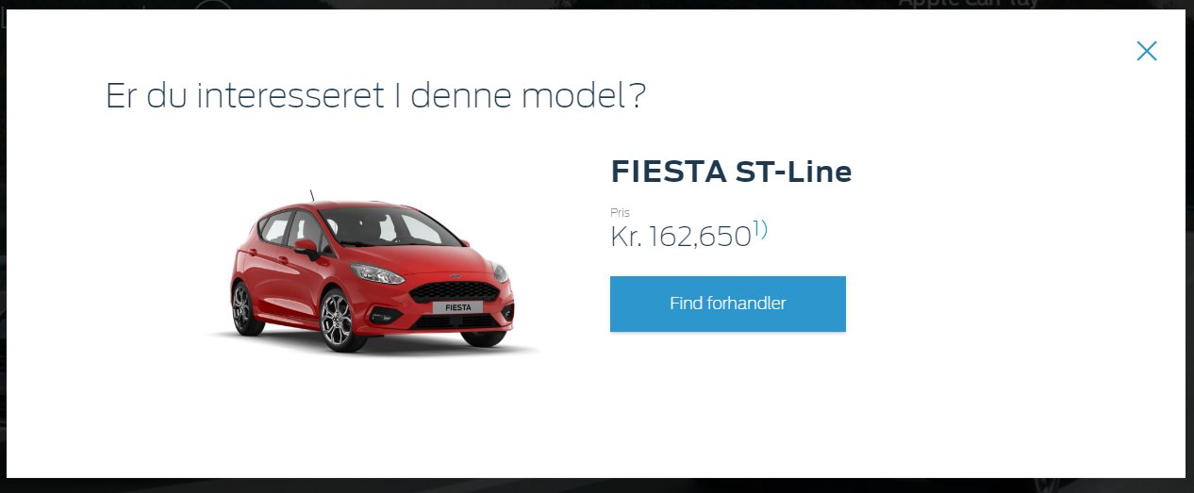

When you click on the “1)” a smaller popup should appear that looks like the below:

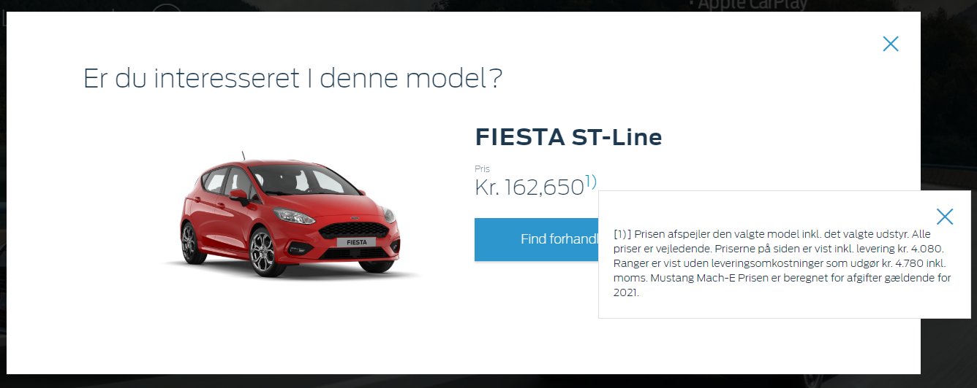

**Browser:**   
All  
  
**Device:**   
All  
  
**Audience rules:**   
All traffic

**QA Links:**

BnP Start and Finish:

<https://www.ford.dk?at_preview_token=MovOiM0b1ex5BMkyZCOxwg%3D%3D&at_preview_index=1_1&at_preview_listed_activities_only=true>

Only on profile script true:

<https://www.ford.dk?at_preview_token=MovOiM0b1ex5BMkyZCOxwg%3D%3D&at_preview_index=1_2&at_preview_listed_activities_only=true>

TDR Drive Link:

<https://www.ford.dk/shop/priser/book-en-proevetur>